Sheffield Local Wildlife Sites Partnership: Criteria for the Selection of Local wildlife Sites

1. Introduction

Although heavily urbanised, Sheffield has a rich diversity of wildlife, habitats and natural environment heritage within the built-up area and also in the attractive countryside around its green suburbs.

The Sheffield Local Wildlife Sites Partnership aims to conserve, maintain and enhance this diversity through a system of Local Wildlife Sites (LWS). These will also be identified in the Local Development Framework.

2. The assessment of suitability of Local Wildlife Sites in Sheffield

There are three main methods by which a potential site may be assessed and proposed to the Local Wildlife Sites Partnership for selection as a Local wildlife Site:

- The principles set out in the Sheffield 1991 nature Conservation Strategy
- The Sheffield Local Red Data List
- The use of criteria based on indicator species and assemblages of species

In each case the Sheffield Local Wildlife Sites Partnership will have reviewed and approved the use of the methodology for the assessment of potential sites and the reassessment of existing sites.

A potential Local Wildlife Site may be assessed and proposed using just one of these methodologies, or any combination of them. The cumulative value of a site across 2 or more methodologies may also be considered. The same is true of sites which for example contain more than one habitat type and/or faunal interest which are assessed using different indicator species and assemblages.

Some further detail and interpretation of the principles of the Sheffield Nature Conservation Strategy is given in section 4 and annexes 1a and 1b. The Sheffield Local Red Data List and Indicator species based criteria are published separately to this document on the Sheffield City Council Website.

3. The Selection of Local Wildlife Sites in Sheffield

The Sheffield Local Wildlife Sites Partnership will consider proposals for new Local Wildlife Sites and decide if a site should be selected as a Sheffield Local Wildlife Site.

The cumulative value of a site across 2 or more methodologies may also be considered, even if the site fails to qualify under any one of the methods of assessing sites. The same is true of sites which for example contain more than one habitat type and/or faunal interest which are assessed using different indicator species and assemblages; an example would be a site with woodland, grassland and/or invertebrate components which have been assessed using indicator species.

In such cases the partnership may decide that the value of a site is cumulatively sufficient to justify its selection as a Local Wildlife Site.

4. Sheffield 1991 Nature Conservation Strategy

The Strategy identifies:

- That Local Wildlife Sites may be of National, regional, City wide or of local value:

- Sites of national or regional value, these have a very high ecological value. These may not have been designated as Sites of Special Scientific Interest as SSSIs as this designation does not aim to comprehensively capture every site of National value but rather a representative set of sites rather than comprehensively capturing every site of national value.
- Sites of City-wide value, these have moderate to high ecological value and may have potential for improvement through sensitive management.
- Sites of local value, These may have only moderate ecological value but have great importance in the local context and may have very significant social and community value.

It is made clear in the Strategy that this is not intended to give a hierarchy of conservation value but rather just the reasons for scheduling.

- That factors beyond the strictly botanical can be considered in selecting Local Wildlife Sites, this includes for example the community value of the site (see extract at annex 1a. This has been expanded into a set of criteria to be used in assessing a site using the Sheffield Nature Conservation Strategy. These are included at annex 1b.

Please refer to the Sheffield Nature Conservation Strategy for further detail:
https://www.sheffield.gov.uk/out--about/parks-woodlands--countryside/ecology-service

Annex 1a: Extract from Sheffield Nature Conservation Strategy in respect of Selection of Local Wildlife Sites
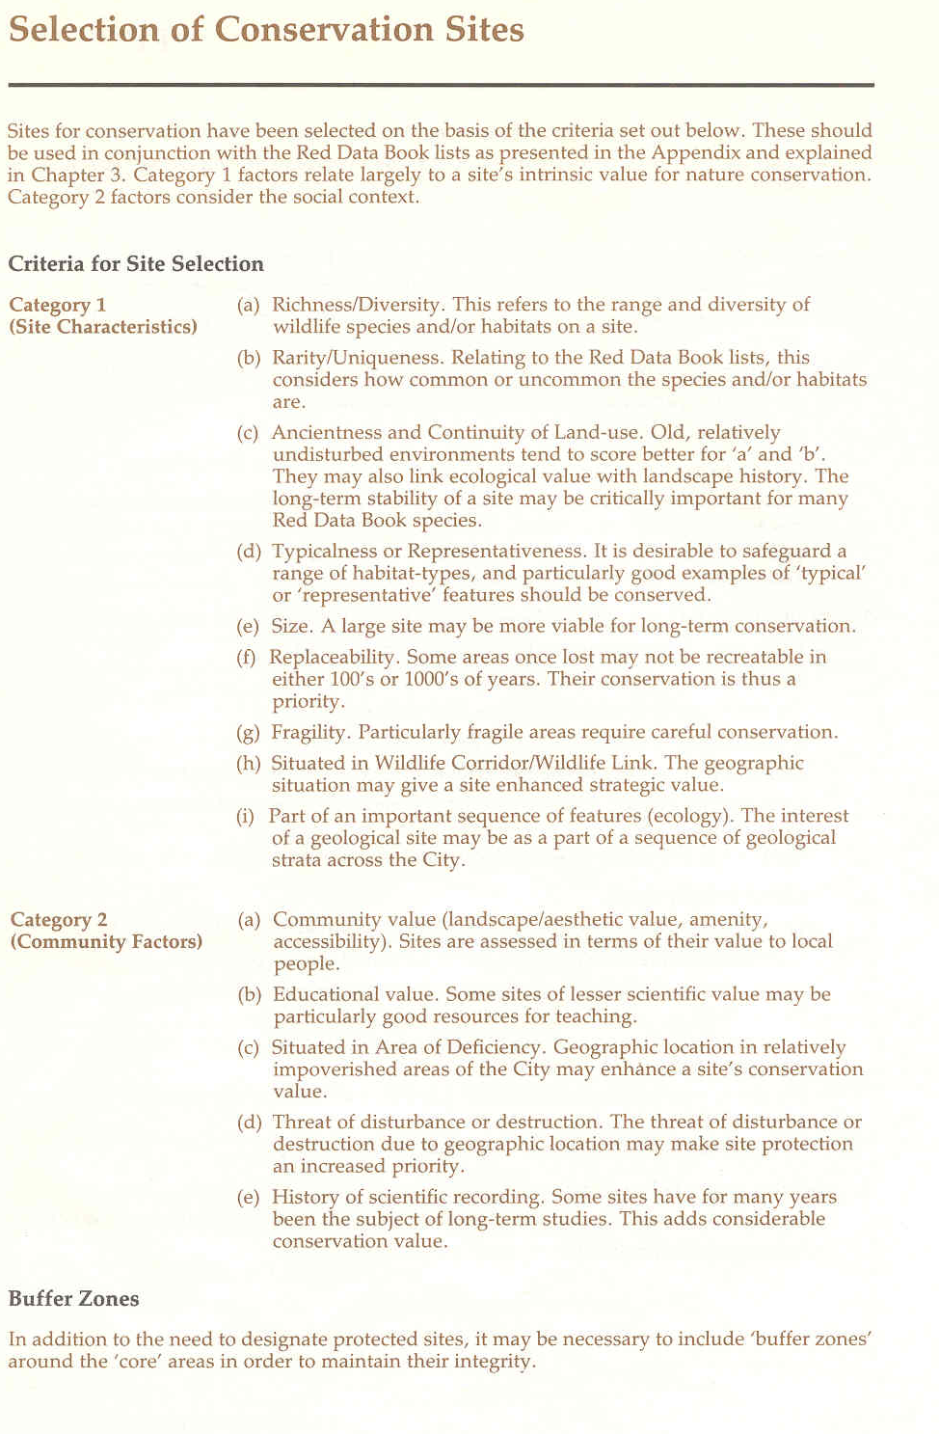

Annex 1b: Selection Criteria for Local Wildlife Sites based on Sheffield Nature Conservation Strategy 1991
For use in assessing sites against the Criteria in the Sheffield Nature Conservation Strategy and completing the corresponding section of Citation sheets for Sheffield Local Wildlife Sites

Evaluation against Local Nature Site selection criteria from 1991 Sheffield Nature Conservation Strategy
SITE CHARACTERISITICS | Sub elements for site characteristics for the site. |  |  |  | COMMUNITY FACTORS | Sub elements for community factors for the site.
 | A | B | C | D |  | A | B | C | D | E
Richness/Diversity |  |  |  |  | Community & Amenity Value
Rarity |  |  |  |  | Educational Value
Continuity of Landuse |  |  |  |  | In an area of deficiency
Typicalness |  |  |  |  | Threat of disturbance/destruction
Size |  |  |  |  | History of scientific recording
Irrepeplaceability
Fragility
Ecological
Position
Part of sequence of features
Significant  Populations |  |  |  |  | Aesthetic Appeal & Landscape
Potential Value |  |  |  |  | Geographical Position
Naturalness |  |  |  |  | Physical & Visual Access

- For each of the site characteristics and community factors there are between 1 and 5 more detailed sub elements/descriptions listed A – E which are described in the tables overleaf.
- For each of the site characteristics and community factors insert a tick or Y if the site meets the description given for any of the sub elements (A-E).
- Where a site characteristics or community factor has less than 5 sub elements this has left spare tick boxes in the table which are not used. These have been greyed out.
- If the site does not fit the description leave the box blank.
Guidelines for tick box: Site Characteristics
Richness/Diversity | A | The site has a high species diversity of flowering plants characteristic of the habitat type (e.g. as defined by the National Vegetation Classification).
Richness/Diversity | B | The site contains a mosaic of three or more habitats.
Richness/Diversity | C | The site contains a range of associated sub-habitats e.g. tall herb vegetation, young open scrub or carr, damp areas, open springs, flushes, ditches, streams, variable slope or aspect, bare soil.
Richness/Diversity | D | The site has importance for invertebrates, mammal, amphibians, reptiles and/or bird life.
Rarity | A | The site contains one or more locally important or threatened species or habitat.
Rarity | B | The site contains one or more nationally important or threatened species or habitat.
Rarity | C | The site contains one or more internationally important or threatened species or habitat.
Rarity | D | All unimproved and good quality semi-improved grassland, ancient woodland is rare and should be selected.
Continuity of Landuse | A | The site is known to be or is probably long established in its current habitat type e.g. pasture, meadow, marsh, woodland, heath.
Continuity of Landuse | B | The site contains archaeological features e.g. ridge-and-furrow marks, dry moats, Deserted Medieval Settlement elements, Strip lynchets etc.
Continuity of Landuse | C | The site or its habitats are maintained under a regime of traditional management e.g., grazing, hay cropping, coppice etc.
Typicalness | A | The site has a good example of its habitat community type (e.g. neutral, acidic, calcareous or marshy grassland). The national, regional or local context should be stated.
Typicalness | B | The site makes a valuable contribution to the range and sequence of the habitat community type in the local area.
Size | A | The site is large enough for its characteristic communities to be relatively unaffected by outside influences.
Irreplaceability | A | Some areas once lost may not be recreatable in either 100’s or 1000’s of years. Their conservation is thus a priority.
Fragility | A | The survival of the habitats within the site, and/or important species it supports, is dependent on continued sensitive management.
Fragility | B | The site and its habitats and/or important species it supports, are relatively sensitive to human disturbance and/or the adverse effects of neighboring land use (e.g. agricultural pesticides, loss/absence of boundary feature, eutrophication, hydrological change).
Fragility | C | The site and its habitats are vulnerable to the encroachment of scrub/carr.
Fragility | D | BAP species present
Ecological Position | A | The site is linked to other areas of semi-natural habitat of the same type or is one of a group of sites in the area (e.g., has a stepping stone function).
Ecological Position | B | The site is associated with other semi-natural habitat (of any type).
Ecological Position | C | The site is close to or part of a wildlife corridor or other connecting linear habitats.
Part of a sequence of features | A | Part of an important sequence of features (ecology).
Significant Populations | A | The site is known to contain an important population, or high proportion, of a particular species occurring in Sheffield (or nationally).
Significant Populations | B | The site is known to contain a species on the edge of its range.
Potential Value | A | It can be demonstrated that diversity, or any other criterion, can be enhanced so as to improve the site’s substantive value, and that the improvements can be realistically achieved.
Potential Value | B | If the site was of sufficient value to be selected, but has been damaged, it is considered to be recoverable.
Naturalness | A | There are areas of agriculturally unimproved and/or good quality semi improved habitat present on site such as grassland/marsh (as defined by Phase I Habitat Survey)

Guidelines for tick box: Community Factors

Community and Amenity Value | A | There is significant evidence of regular use of the site by the public, (e.g. signs of informal access, footpaths etc.)
Community and Amenity Value | B | The site contains specific community interests, e.g. mammal interest, invertebrate interest or attractive vegetation.
Community and Amenity Value | C | The site has general recreational appeal e.g. through its peacefulness, seclusion, inclusion of good picnic sites, or general ‘countryside appeal’.
Community and Amenity Value | D | The site has specific links with community history, e.g. it includes old canal or railway lines.
Educational Value | A | The site has existing use as an educational resource.
Educational Value | B | The site includes a mosaic of different habitat types.
Educational Value | C | The site includes transitional habitats.
Educational Value | D | The site includes aquatic features (and there is easy and safe access to the waters edge e.g. is there a “dipping” platform).
Educational Value | E | The site is near to a school which could potentially use it
In an area of deficiency | A | Geographic location in relatively impoverished areas of the City may enhance the sites conservation value.
Threat of disturbance/ destruction | A | The threat of disturbance or destruction due to geographic location may make site protection an increased priority.
Recorded History | A | The recorded history is known for the site.
Recorded History | B | Records for the site extend back to before World War II.
Recorded History | C | Records for the site extend back to before the start of the 20th Century or before the 1st Edition O.S. Map.
Aesthetic Appeal and Landscape Character | A | The site is characteristic of the Sheffield Landscape Area within which it is found.
Aesthetic Appeal and Landscape Character | B | The site contributes to local landscape character and appeal.
Aesthetic Appeal and Landscape Character | C | The site provides a variety of internal views.
Aesthetic Appeal and Landscape Character | D | The site supports attractive vegetation, e.g. a colourful meadow flower community.
Geographical Position | A | The site is isolated from other areas of semi-natural habitat.
Geographical Position | B | The site is situated within walking distance of residential communities.
Physical and Visual Access | A | There is formal access to the site, by means of a definitive public right of way.
Physical and Visual Access | B | There is informal access to the site, e.g. through unrestricted entrance ways and casual footpaths which are obviously well used.
Physical and Visual Access | C | There is disabled access to the site.
Physical and Visual Access | D | Visual access is generally unrestricted e.g. the site is not hidden by local topography or built development, or the site is on a prominent hillside.

This has been based on a case study from North Yorkshire

